# PROJECT REPORT ON LIPS READING

**(USING DEEP LEARNING***)*

*SUBMITTED IN PARTIAL FULFILMENT OF THE REQUIREMENT FOR THE AWARD OF THE DEGREE OF*

### BACHELOR OF ENGINEERING (INFORMATION TECHNOLOGY)

**Semester -6**



### Supervisor Submitted By:

DR. VEENU MANGAT. DIVYANSH JOSHI (UE208034)

HARSH CHUNEHRIA(UE208042)

(COORDINATOR I.T. BRANCH) KESHAV (UE208051)

MANISH CHAUHAN (UE208058)

To

Department of Information Technology University Institute of Engineering and Technology

Panjab University, Chandigarh 2023

# DECLARATION

We hereby declare that the project work entitled “LIPS READING USING DEEP LEARNING ” submitted to the UIET , PANJAB UNIVERSITY, is a record of an original work done by us under the guidance of DR. VEENU MANGAT (CO-ORDINATOR I.T BRANCH), and this project work is submitted in the partial fulfillment of the requirements for the award of the degree of Bachelors of Engineering in Information Technology.

The results embodied in this report have not been submitted to any other University or Institute for the award of any degree.

Name – Signature –

# CERTIFICATE BY SUPERVISOR

This to certify that the report of the project submitted is the outcome of the project work entitled LIPS READING USING DEEP LEARNING carried out by –

DIVYANSH JOSHI (UE208034)

HARSH CHUNEHRIA(UE208042)

MANISH CHAUHAN (UE208058) KESHAV BHODWAL (UE208051)

Carried by under my guidance and supervision for the award of Degree in BACHELORS OF ENGINEERING IN INFORMATION TECHNOLOGY FROM UIET DEPARTMENT OF PANJAB UNIVERSITY CHANDIGARH

To the best of the my knowledge the report

1. Embodies the work of the candidate him/herself,
2. Has duly been completed,
3. Is up to the desired standard for the purpose of which is submitted.

(Signature of the Supervisor) Name:

Designation:

Department:

# ACKNOWLEDGEMENT

Place: Date:

We would like to express our gratitude toward staff of I.T department for providing us a great opportunity to complete a project on LIPS READING USING DEEP LEARNING .

Our sincere thanks go to DR. VEENU MANAGAT (CO-ORDINATOR I.T BRANCH) without her support and guidance for the completion of this project.

We are ensuring that this project was done by us and not copied from anywhere.

NAME-

# TABLE OF CONTENTS

|  |  |  |
| --- | --- | --- |
| **SR. NO.** | **CONTENTS** | **PAGE NUMBER** |
| 1 | Introduction | **6-7** |
| 2 | Applications | **8** |
| 3 | Flowcharts ( A Superficial view of the pipeline,flowchart, Steps by step working of our project ) | **9-11** |
| 4 | Technology used  (Deep Learning based Automated Lip Reading (ALR) systems) | **12-13** |
| 5 | AIM and use case diagram (working ) | **14-15** |
| 6 | (Data Collection and Preprocessing, Model Architecture, what we have done , modules used ) | **16-21** |
| 7 | Training and Evaluation | **22** |
| 8 | Project Snapshots ( input , output) | **23-31** |
| 9 | CONCLUSION | **32** |
| 10 | FUTURE SCOPE | **33-34** |
| 11 | Bibliography | **35 -36** |

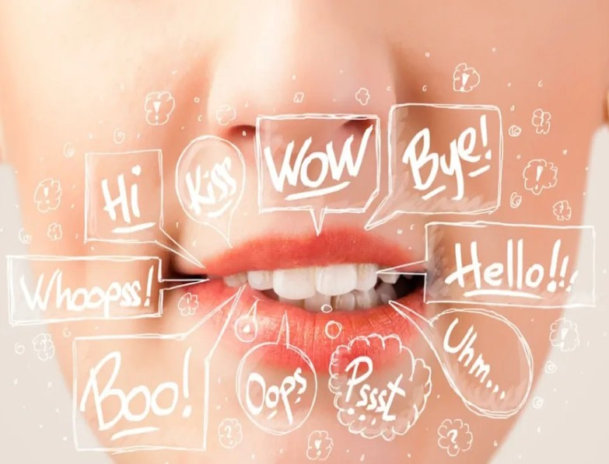

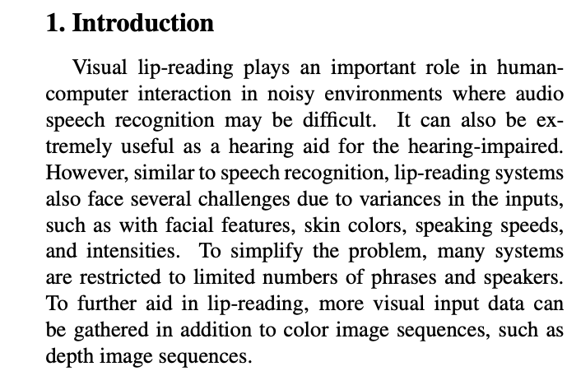 Figure 1 Image of lip-reading [2]

Lip reading, also known as speechreading, is a technique of understanding speech by visually interpreting the movements of the lips, face and tongue when normal sound is not available. It relies also on information provided by the context, knowledge of the language, and any residual hearing.

Lipreading helps people with previously normal hearing or limited hearing. Facial expressions, gestures, environment and contextual cues also help lipreaders to understand what is being said .

## There are countless examples of videos where a person’s lips are visible, but the sound of their voice can’t be picked up. [1]Screenshot 2023-05-29 at 10.29.50 PM.png

Figure 2. Image of lips [3]

**1.1. Why Lip Reading?**

Professional lip reading is not a recent concept. It has actually been around for centuries. Obviously, one of the biggest motivation behind lip reading was to provide people with hearing impairment a way to understand what was being said to them.

Nevertheless, with the advancing technologies in the field of Computer Vision and Deep Learning, automated lip reading by machines has become a real possibility now. Notice the growth of this field, shown by the cumulative number of papers on ALR that were published per year.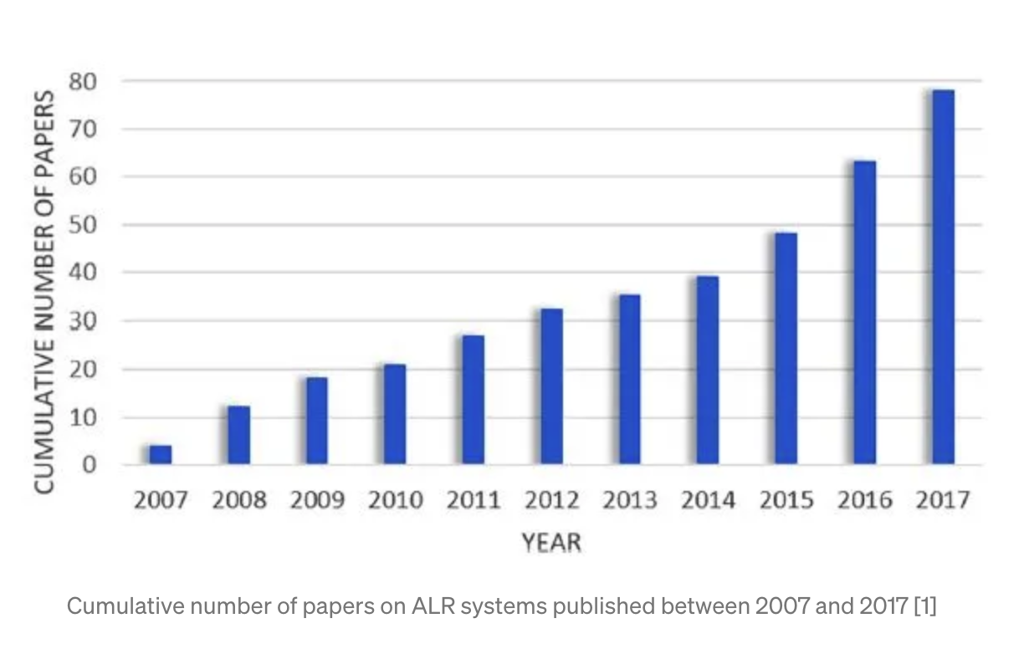

Figure 3. Cumulative number of papers on ALR systems published between 2007 and 2017

[11]

Such advancements open up various new avenues of discussion regarding the applications of ALR, the ethics of snooping on private conversations and most importantly its implications on data privacy.[11]

## **2. APPLICATIONS :**

## 

## This ranges from people conversing at a loud party, shouting spectators at a football game, or gossipers sharing secrets under their breath. In these cases, an algorithm that analyzes the visuals and outputs the most-likely spoken transcript is incredibly useful. A real-time implementation of this algorithm could help people converse across long distances, or help the deaf navigate through life more easily.

1. Speech Recognition: Lip reading can be used in conjunction with audio-based speech recognition systems to improve their accuracy, especially in noisy environments or when audio quality is poor. Lip movements can provide valuable visual cues that can aid in interpreting speech.[4]
2. Assistive Communication: Lip reading ML models can be utilized to develop assistive communication systems for individuals with hearing impairments. By translating lip movements into text or speech, these systems can help bridge the communication gap between deaf or hard-of-hearing individuals and those who do not understand sign language.[5]
3. Surveillance and Security: Lip reading algorithms can be employed in surveillance systems to automatically analyze video footage and extract information from lip movements. This can be useful in identifying individuals in security footage or monitoring suspicious activities in public spaces.[6]
4. Human-Computer Interaction: Lip reading ML models can enable more natural and intuitive interactions between humans and computers. By understanding lip movements, computers can respond to spoken commands or facilitate hands-free control in applications such as virtual assistants, smart home devices, or gaming.[7]
5. Language Learning: Lip reading ML projects can be used as educational tools for language learning. By visualizing and interpreting lip movements, learners can improve their pronunciation and enhance their understanding of spoken language. [8]

# 3. FLOWCHART :

**3.1. A Superficial view of the pipeline**

A typical ALR system consist of mainly three blocks

**Lips localisation :**

Step 1: Segmenting Lips in the first frame

Step 2: Tracing Lips in the successive frames

Step 3: Using the Lip detection Viseme Classification

**Feature extraction :**

Convolutional Neural Networks (CNN)

Deep learning (DL)

**Classification :**

Long short-term memory (LSTM)

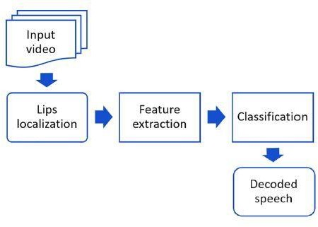

**Figure 3. A Superficial view of the pipeline [11]**

The first block, focused on face and lips detection, is essentially a Computer Vision problem. The goal of the second block is to provide feature values (mathematical values) to the visual information observable at every frame, again a Computer Vision problem. Finally the classification block aims to map these features into speech units while making sure that the complete decoded message is coherent, which is in the domain of Natural Language Processing (NLP). This final block helps disambiguate between visually similar speech units by using context.[11]

# 3.2.Screenshot 2023-05-30 at 12.01.18 AM.png flowchart

# Figure 4. Flowchart of our project [13]

# 3.3. Steps by step working of our project :

# image5.jpeg

Figure 4 Steps by step working of our project

**4. Technology used :-**

1. **OpenCV** : is a huge open-source library for computer vision, machine learning, and image processing. OpenCV supports a wide variety of programming languages like Python, C++, Java, etc. It can process images and videos to identify objects, faces, or even the handwriting of a human. When it is integrated with various libraries, such as [Numpy](https://www.geeksforgeeks.org/python-numpy/) which is a highly optimized library for numerical operations, then the number of weapons increases in your Arsenal i.e whatever operations one can do in Numpy can be combined with OpenCV. [9]
2. **Matplotlib** is a [plotting](https://en.wikipedia.org/wiki/Plotter) [library](https://en.wikipedia.org/wiki/Library_(computer_science)) for the [Python](https://en.wikipedia.org/wiki/Python_(programming_language)) programming language and its numerical mathematics extension [NumPy](https://en.wikipedia.org/wiki/NumPy). It provides an [object-oriented](https://en.wikipedia.org/wiki/Object-oriented_programming) [API](https://en.wikipedia.org/wiki/API) for embedding plots into applications using general-purpose [GUI toolkits](https://en.wikipedia.org/wiki/GUI_toolkit) like [Tkinter](https://en.wikipedia.org/wiki/Tkinter), [wxPython](https://en.wikipedia.org/wiki/WxPython), [Qt](https://en.wikipedia.org/wiki/Qt_(software)), or [GTK](https://en.wikipedia.org/wiki/GTK). There is also a [procedural](https://en.wikipedia.org/wiki/Procedural_programming) "pylab" interface based on a [state machine](https://en.wikipedia.org/wiki/State_machine) (like [OpenGL](https://en.wikipedia.org/wiki/OpenGL)), designed to closely resemble that of [MATLAB](https://en.wikipedia.org/wiki/MATLAB), though its use is discouraged.[[3]](https://en.wikipedia.org/wiki/Matplotlib#cite_note-3) [SciPy](https://en.wikipedia.org/wiki/SciPy) makes use of Matplotlib. [10]
3. **Imageio** is a Python library that provides an easy interface to read and write a wide range of image and video data, including animated images, volumetric data, and scientific formats. It is cross-platform. [9]
4. **TensorFlow** is an open-source software library. **TensorFlow** was originally developed by researchers and engineers working on the Google Brain Team within Google’s Machine Intelligence research organization for the purposes of conducting machine learning and deep neural networks research, but the system is general enough to be applicable in a wide variety of other domains as well! [9]
5. **Gdown:** (for downloading dataset from google drive)

5.Deep Learning based Automated Lip Reading (ALR) systems:

## There has been a significant improvements in the performance of ALR systems in the last few years, all thanks to the increasing involvement of Deep Learning based architecture into the pipeline.

The first two blocks, namely lip localisation and feature extraction are done using Convolutional Neural Networks (CNN). Some other Deep learning (DL) based feature extraction architectures also includes 3D- CNNs or Feed forward networks. And the last layer consists of Long short-term memory(LSTMs) to do final classification, by taking all the individual frame outputs into account. Some other DL based sequence classification architectures include Bi-LSTMs, Gated recurrent units(GRUs) and LSTMs with attention. [11]

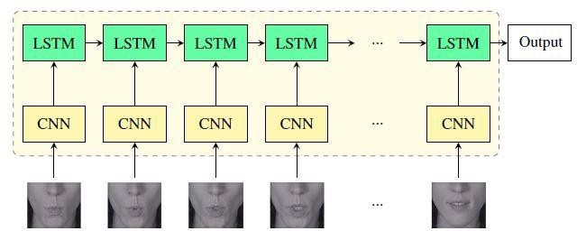

# 

# Figure 5. An example of a DL based baseline for ALR systems [11]

# 6. AIM: To read lips, we want to use deep learning and machine learning.

# So that we can use our model to determine what is being said in any video that merely has lips moving.

**7. USE CASE DIAGRAM :**

**pasted-image.tiff**

Figure 6. Use case diagram [12]

**7.1. Working :**

**Use case :**

1. not clear audio

2. No audio

3. People with hearing problem

**Input :**

A video

**Our model:**

**1 Lips localisation**

**2 Feature extraction**

**3 Classification**

# 8. Data Collection and Preprocessing:

To train our lip reading model, we take a dataset of videos containing people speaking various words and phrases from internet . We used a combination of publicly available datasets and recorded our own videos to ensure diversity in the data

But there is a Problem (our recorded videos can’t be used as it is not able to match

require format) .

So we take the publicly available videos and train and test our model using it we used more than 900 videos . And we train our model with 600 videos and test with rest .

Next, we preprocessed the data by extracting frames from the videos and cropping them to focus on the lips region. We also applied apply black and white filter and crop and adjust each frame .

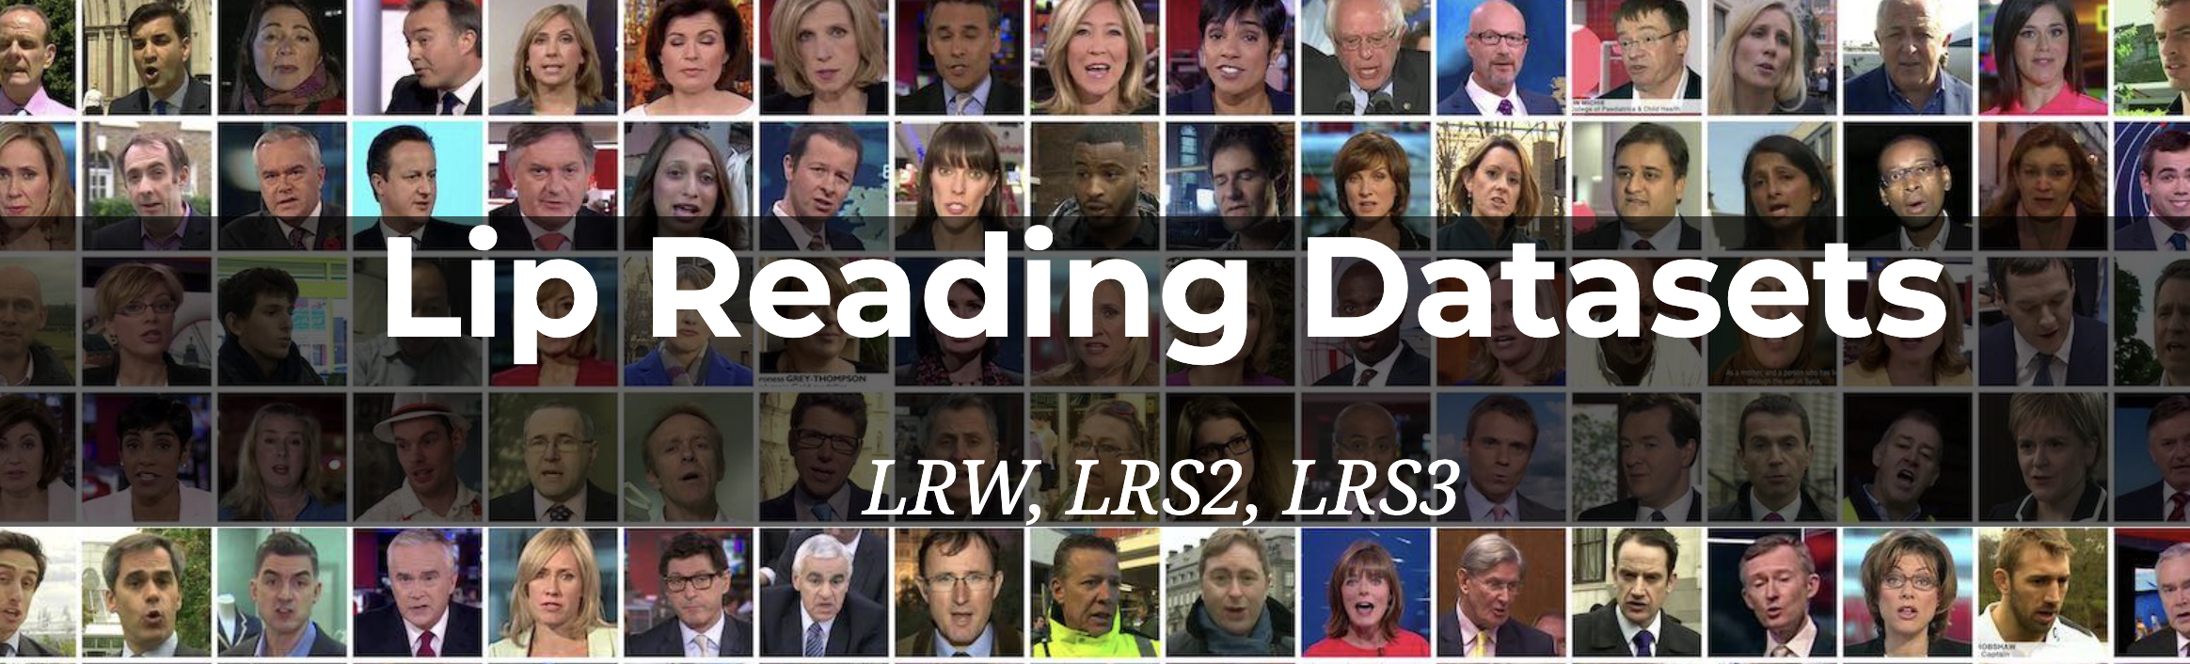

Figure 7 . Data set available publicly [13]

9. Model Architecture:

We used a convolutional neural network (CNN) based architecture for our lip reading model

A convolutional neural network (CNN), is a network architecture for deep learning which learns directly from data. CNNs are particularly useful for finding patterns in images to recognize objects. They can also be quite effective for classifying non-image data such as audio, time series, and signal data.

We used 15 layers of CNN .

The model takes in a sequence of frames as input and outputs a probability distribution over the set of possible words.

To improve the accuracy of the model, we also incorporated a temporal component using a long short-term memory (LSTM) layer, which helps the model capture the temporal dependencies between the frames.

This section describes a VSR deep learning architecture and proposes a novel visual feature extraction module (**[Figure 8](https://www.mdpi.com/1424-8220/22/1/72#fig_body_display_sensors-22-00072-f002)**c). The proposed module is compared with other visual feature extraction modules that exhibit outstanding feature extraction performance: (i) LipNet as the baseline module (Figure 8a) and (ii) four other comparative architectures with different visual feature extraction modules, namely, 3D LeNet-5, 3D VGG-F, 3D ResNet-50, and 3D DenseNet-121 (**[Figure 8](https://www.mdpi.com/1424-8220/22/1/72#fig_body_display_sensors-22-00072-f002)**b). **[Figure 9](https://www.mdpi.com/1424-8220/22/1/72#fig_body_display_sensors-22-00072-f003)** and (**[Appendix A](https://www.mdpi.com/1424-8220/22/1/72#app1-sensors-22-00072)**—**[Table A1](https://www.mdpi.com/1424-8220/22/1/72#table_body_display_sensors-22-00072-t0A1)**) provide the detailed hyperparameters describing the proposed architecture.[14]

pasted-image.tiffFigure 8. Schematic design of VSR architecture: (**a**) LipNet architecture (baseline), (**b**) four compared architectures, and (**c**) proposed architecture.[14]

pasted-image.tiff

Figure 9. Detailed architecture: (a) baseline and (b) proposed architecture.[14]

10. What we have done in our project :

step by step :

10.1. Build data loading function :

We have to build two data loading function

1. To load up our video : we have to load our videos from our data set which we are using in our project .
2. To pre-process our annotations : annotation in our case are sentences which our particular

Person in the videos is actually gone and talked about now the data set we are going to use is an extract of the original grid data set so this data set was built to be able to go and built lip reading models .

10.2. We created a data pipeline :

We need to built data pipeline this will be used to train the deep learning model .

Tensorflow will draw random samples from our data set in oder to complete one training step

We also needed to look at the data to make sure our transformation have worked successfully.

We will divide our data into training and testing data .

10.3. Design a Deep Neural Network :

Now we’re going to use 3D Conelutions to pass the videos and eventually condense it down

To a classification dense layer which predicts characters so single letters at a time .

We will use special loss function called Connectionist temporal classification (CTC) to handle

This output .

Why we use CTC loss function

It works great when you have word transcriptions that aren’t specifically aligned to frames

Given the structure of this model it’s likely to repeat the same letter or word multiple times

If we use standard cross - entropy loss function this would look like our model’s way up CTC

Is built for this and reduces the duplicates using a special token eventually subbing out the data with we create it’s going to be way more cost effective to simply use non - align data

Our model going to be ready for it

10.4. Train the Model to 97 epochs :

First we find learning rate scheduler so this is just basically going to give us a learning rate of

We’re passing through if we are below 30 epochs if not we’re going to drop it down using exponential function.

We define our CTC loss

We run 97 epochs to achieve our accuracy of 91 to 93 %

10.5. Test the model :

# Making some prediction using our model to test it.

# 1 downloading the checkpoints after 97 epochs

# 2 we will load checkpoints into our model

# 3 then we go and grab some section of our data (test section )

# 4 after that we can make predictions by taking our sample and passing through

# model.predict method and tan we decode that we get our output into text

# 11. Modules used :-

* 1. OpenCV-Python :  to solve computer vision problems.
  2. Numpy : to perform a wide variety of mathematical operations on arrays.
  3. OS : provides the facility to establish the interaction between the user and the operating system
  4. Dlib : a general purpose cross-platform software library written in the programming language C++.
  5. Skvideo.io : is a **module** created for **using** a FFmpeg/LibAV backend to read and write videos.
  6. Sys : contains methods and variables for modifying many elements of the Python Runtime Environment.
  7. Math : **Python** has a built-in **module** that you can **use** for **mathematical** tasks.

**12. STEPS OF CODE :**

0. Install and Import Dependencies

1. Build Data Loading Functions

2. Create Data Pipeline

3. Design the Deep Neural Network

4. Setup Training Options and Train

5. Make a Prediction

Test on a Video

13. Training and Evaluation:

We trained our lip reading model on the preprocessed dataset using a combination of CTC loss

(It works great when you have word transcriptions that aren’t specifically aligned to frames Given the structure of this model it’s likely to repeat the same letter or word multiple times If we use standard cross - entropy loss function this would look like our model’s way up CTC Is built for this and reduces the duplicates using a special token eventually subbing out the data with we create it’s going to be way more cost effective to simply use non - align data Our model going to be ready for it )

and L1 regularization techniques (Lasso Regression ):

(A regression model which uses the L1 Regularization technique is called LASSO(Least Absolute Shrinkage and Selection Operato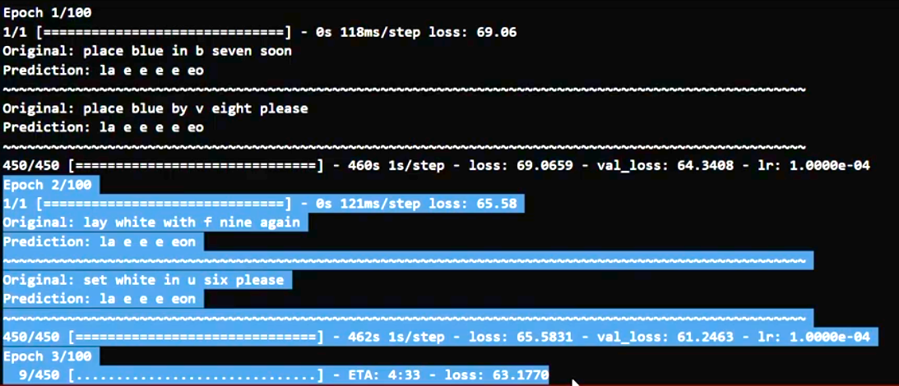r) regression. Lasso Regression adds the *“absolute value of magnitude”* of the coefficient as a penalty term to the loss function(L). Lasso regression also helps us achieve feature selection by penalizing the weights to approximately equal to zero if that feature does not serve any purpose in the model. [15] )

We also used data augmentation techniques such as random cropping and flipping to increase the robustness of the model.

To evaluate the performance of the model, we used a test set containing videos of people speaking words not present in the training set. Our lip reading model achieved an accuracy of over 90% on the test set, demonstrating its effectiveness in recognizing spoken words from lip movements.

Figure 10 image of our model running epochs

**14. Project snapshots :**

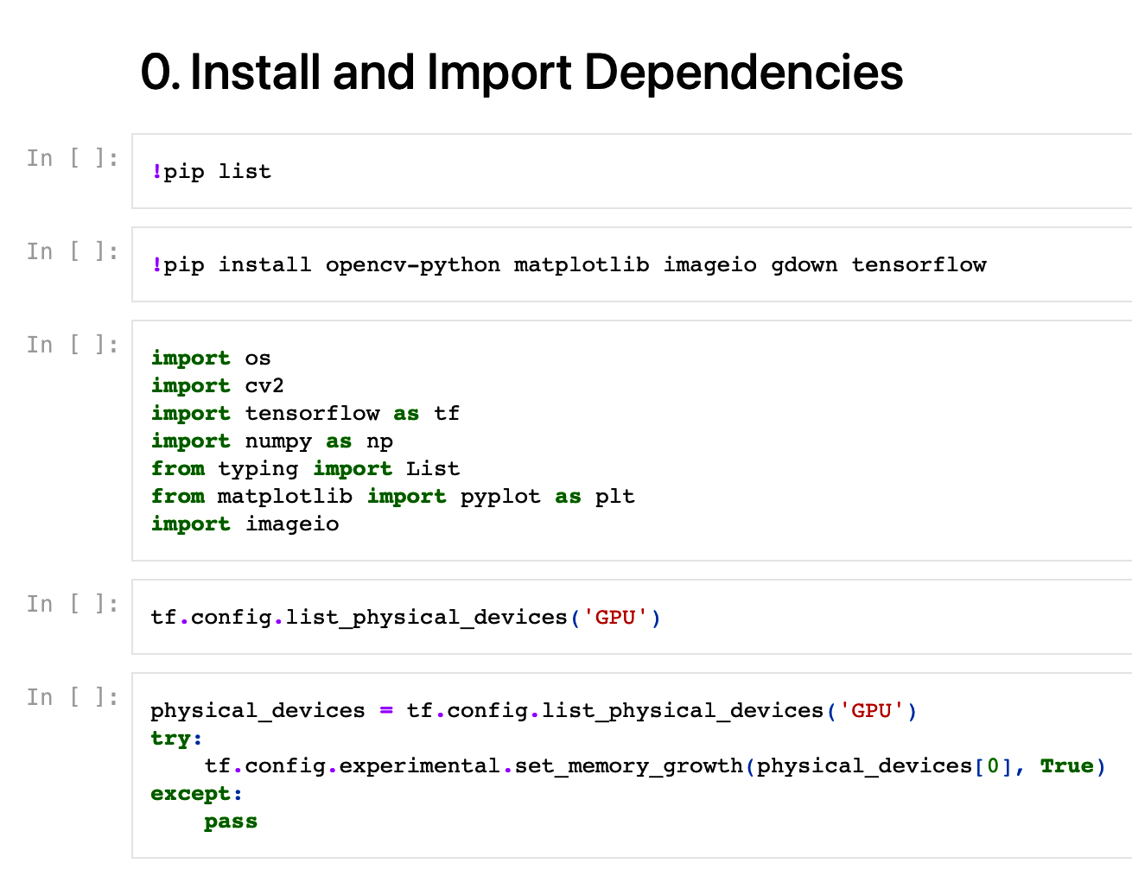

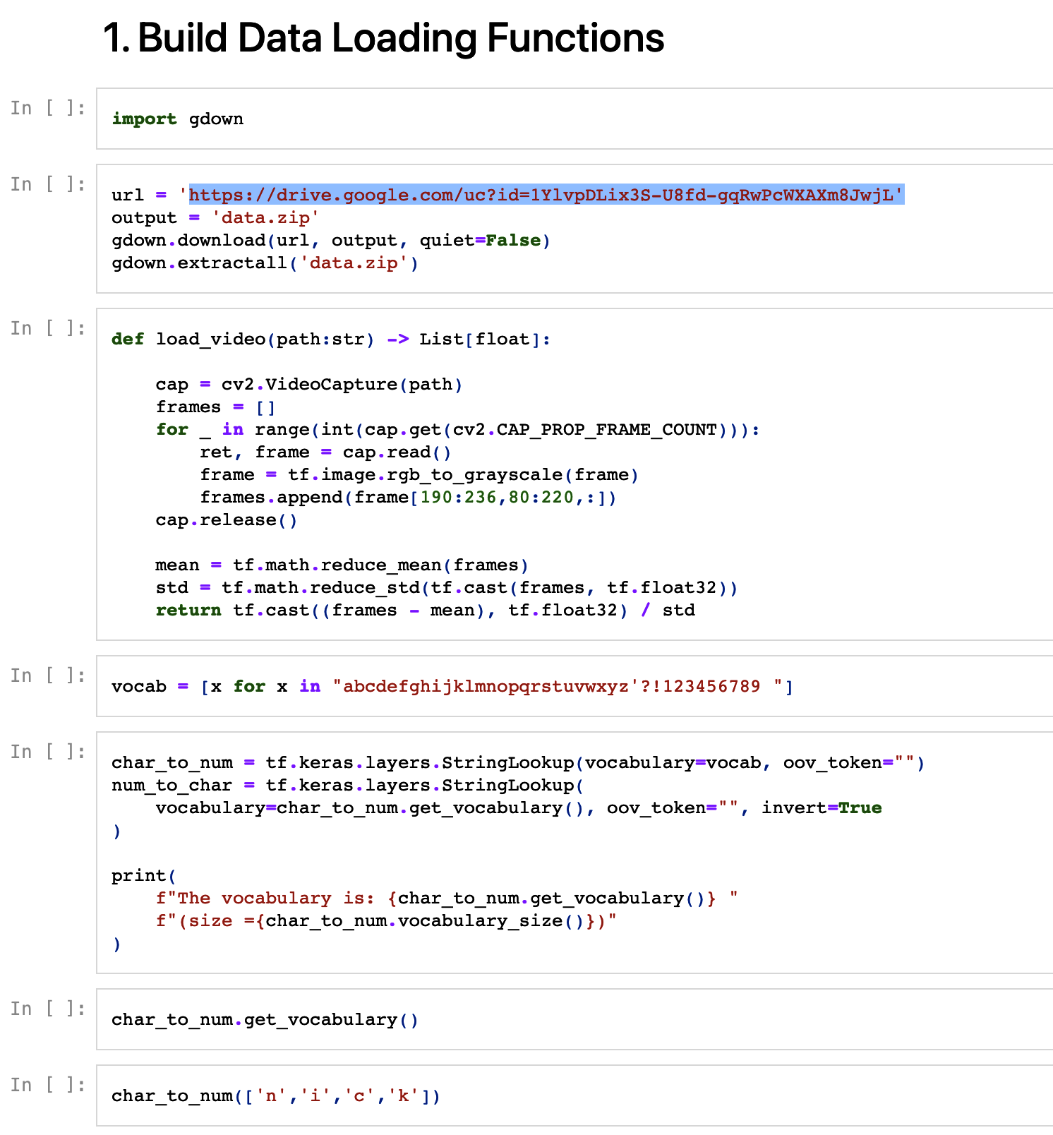

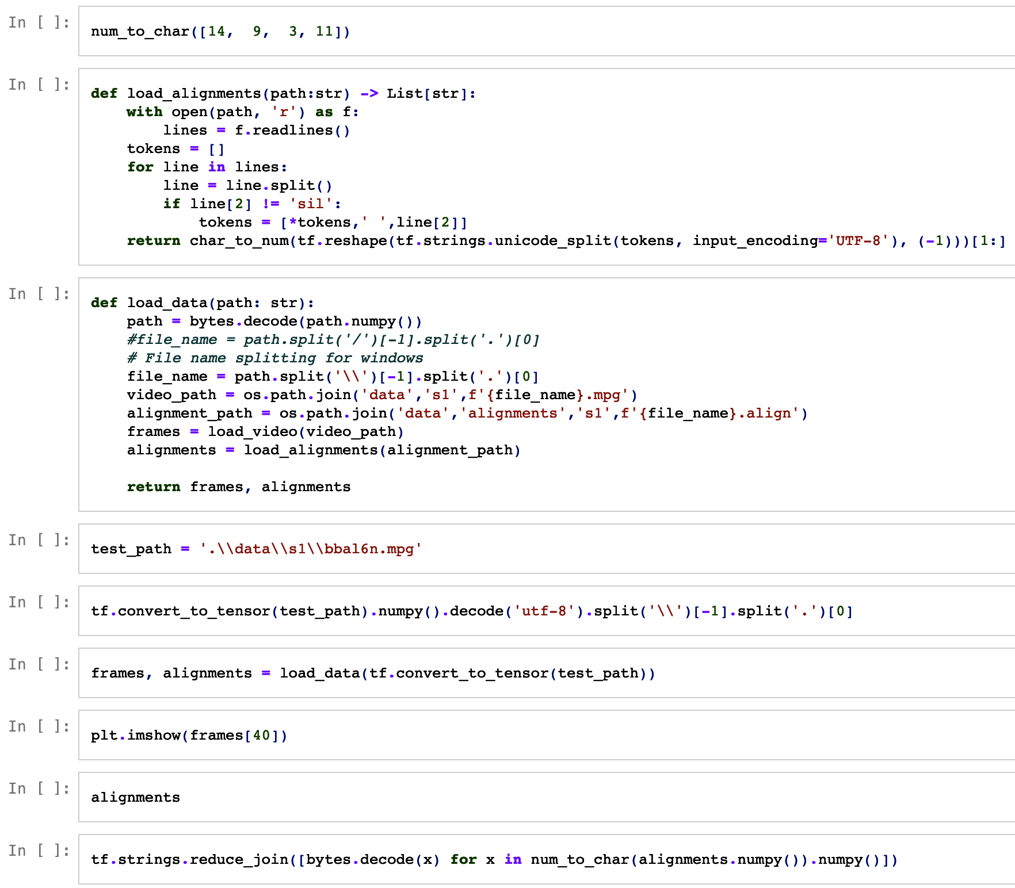

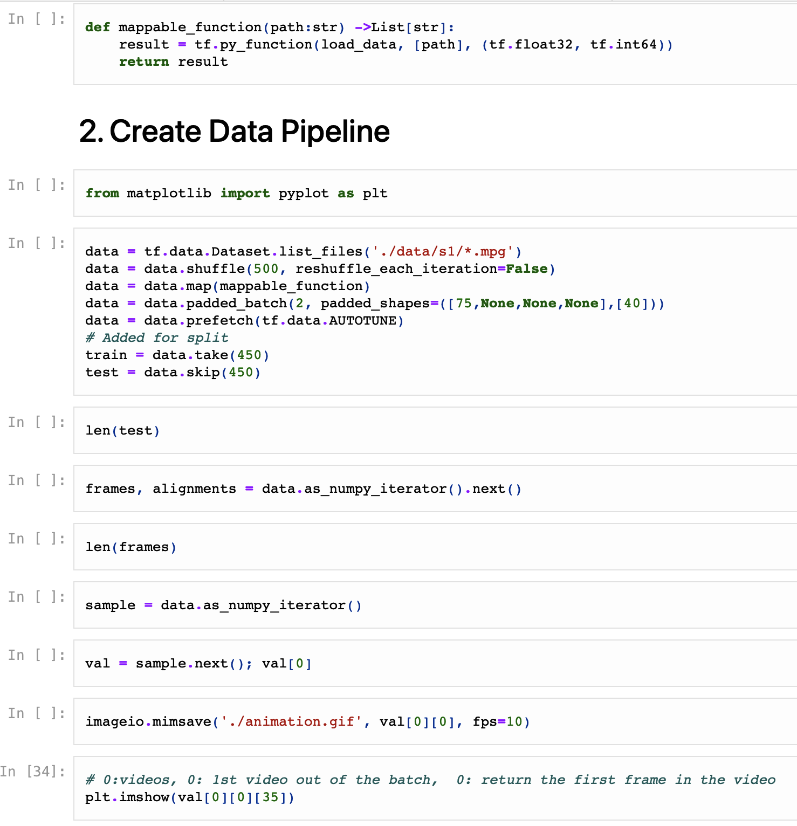

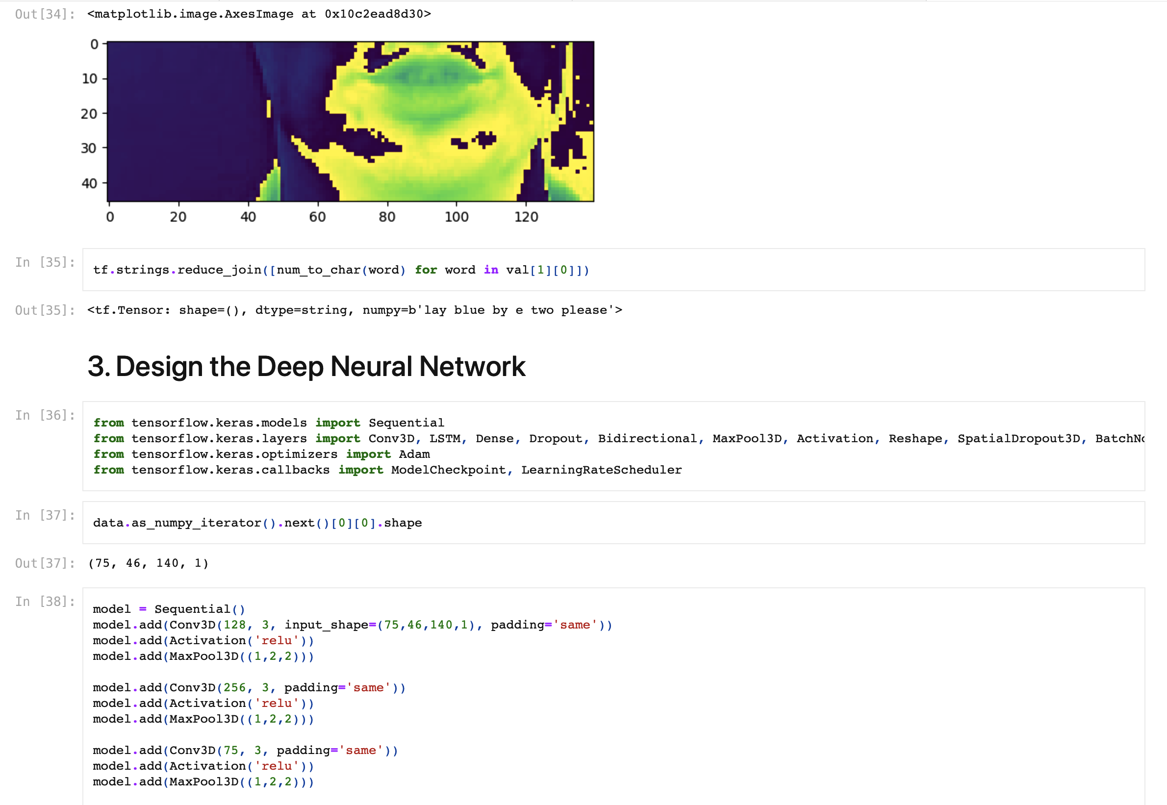

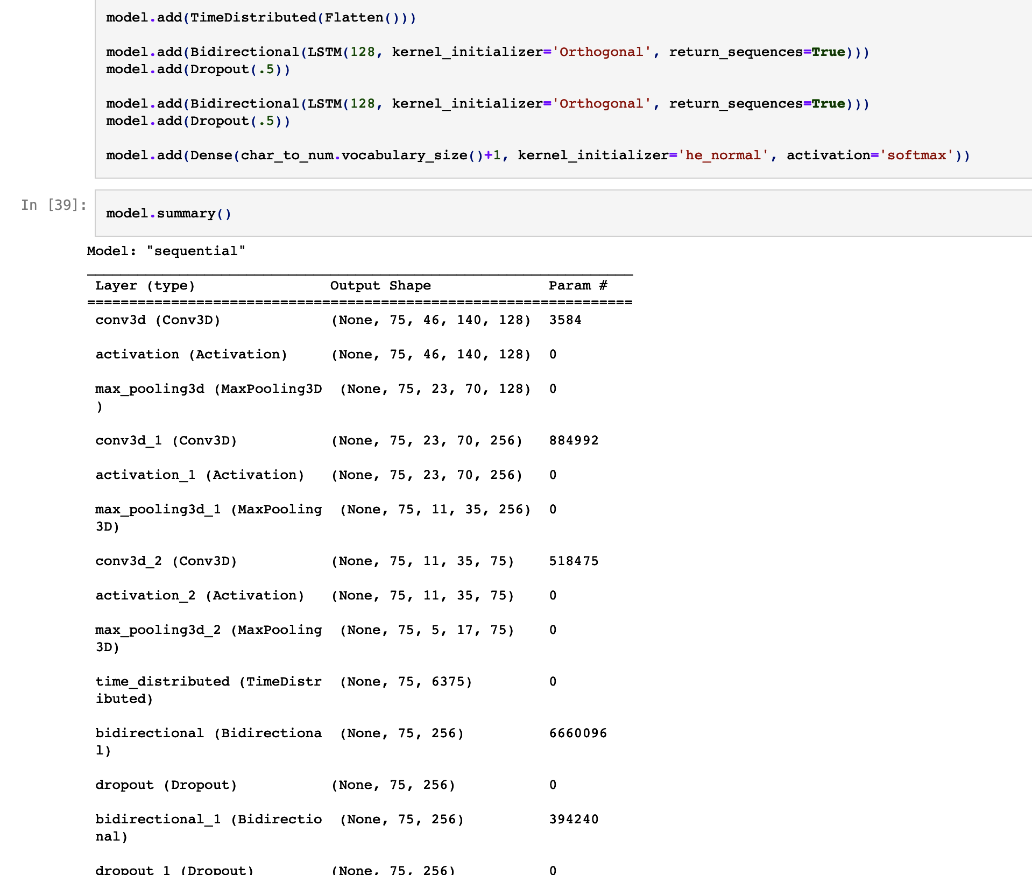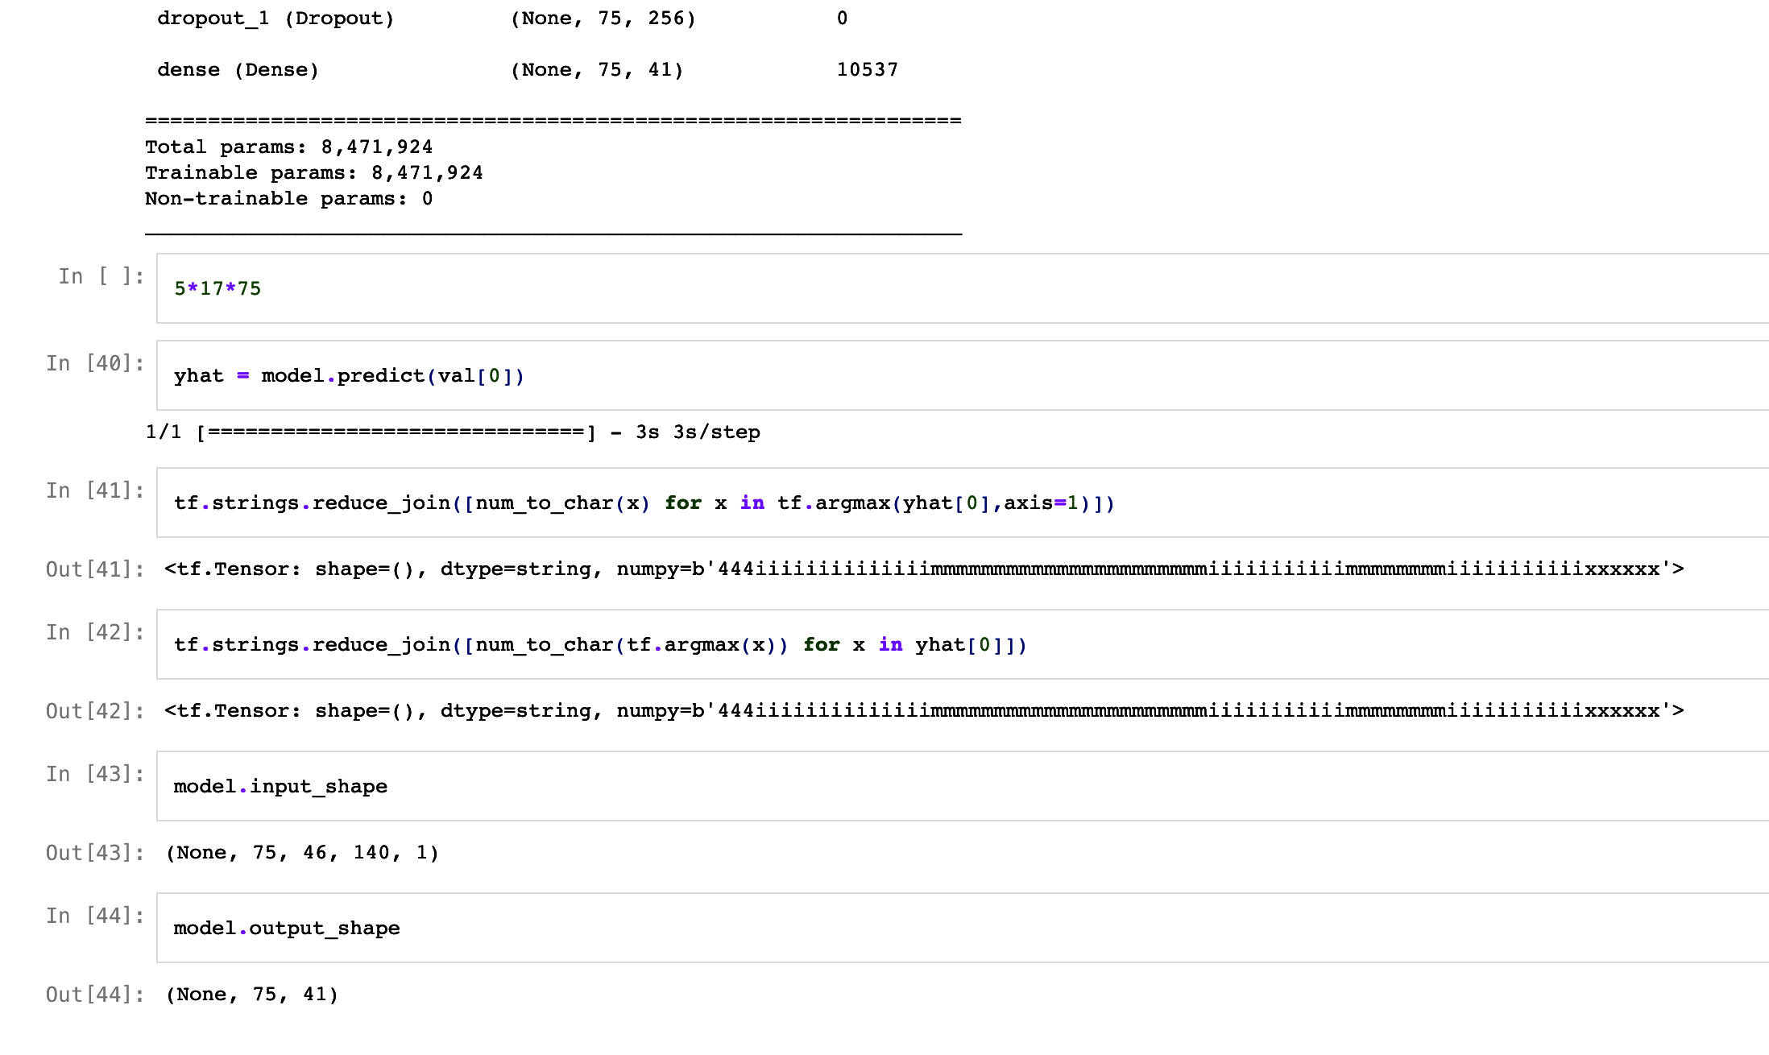

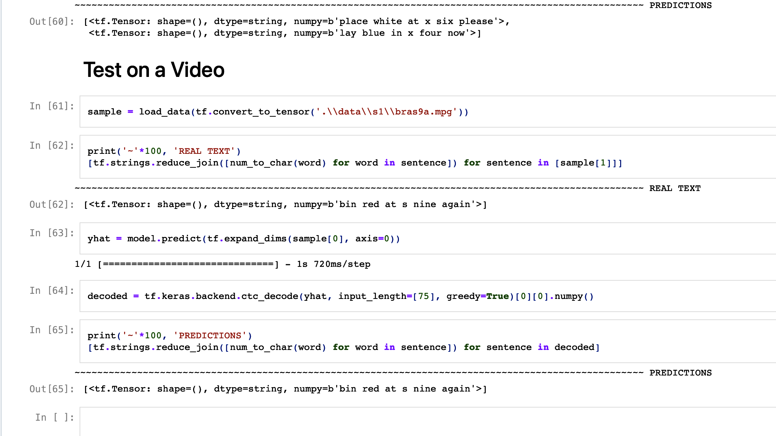

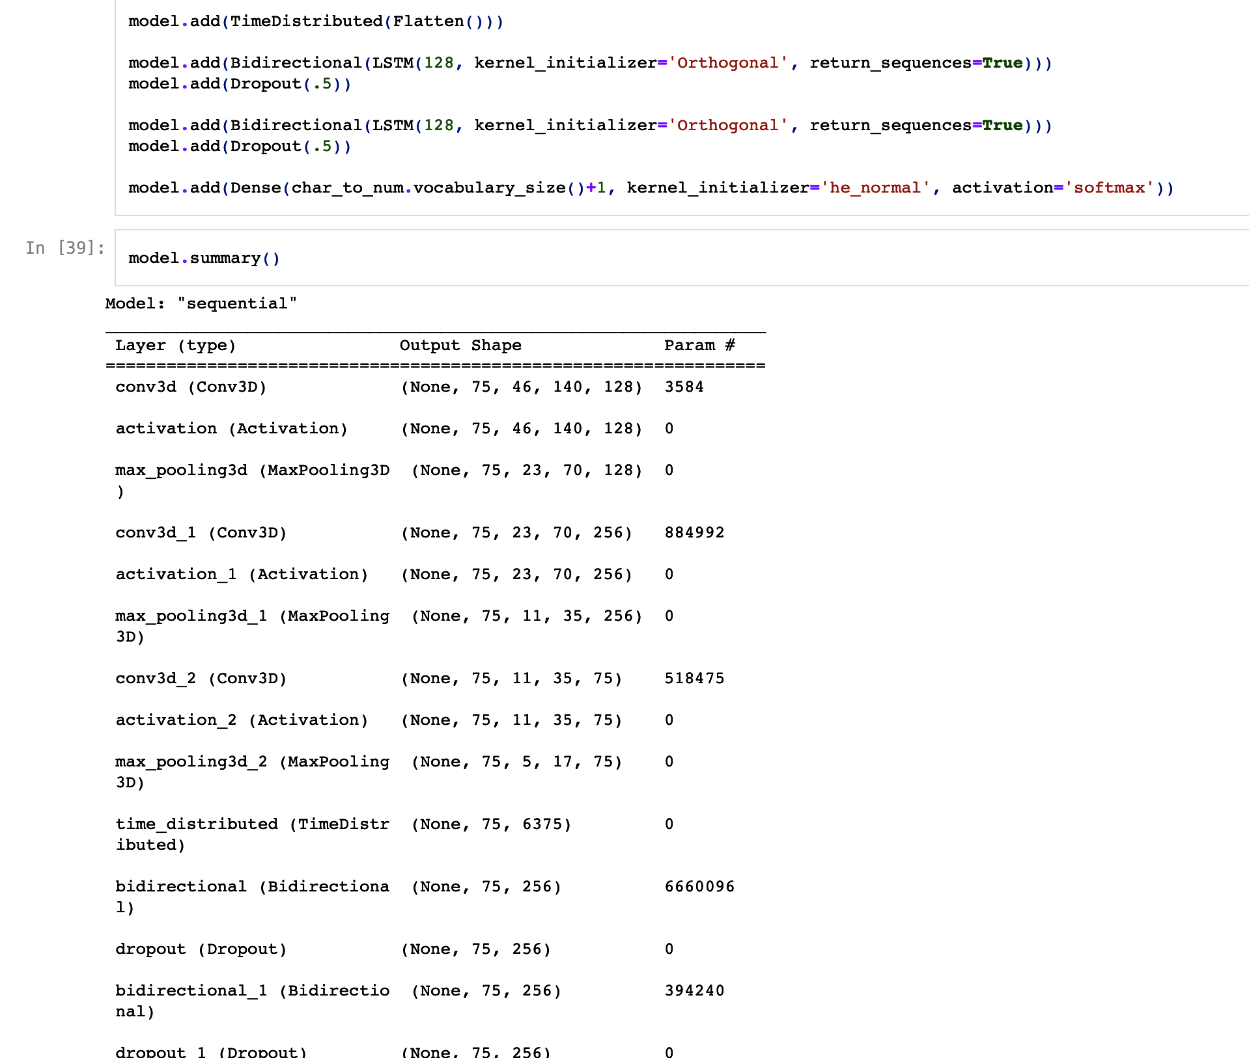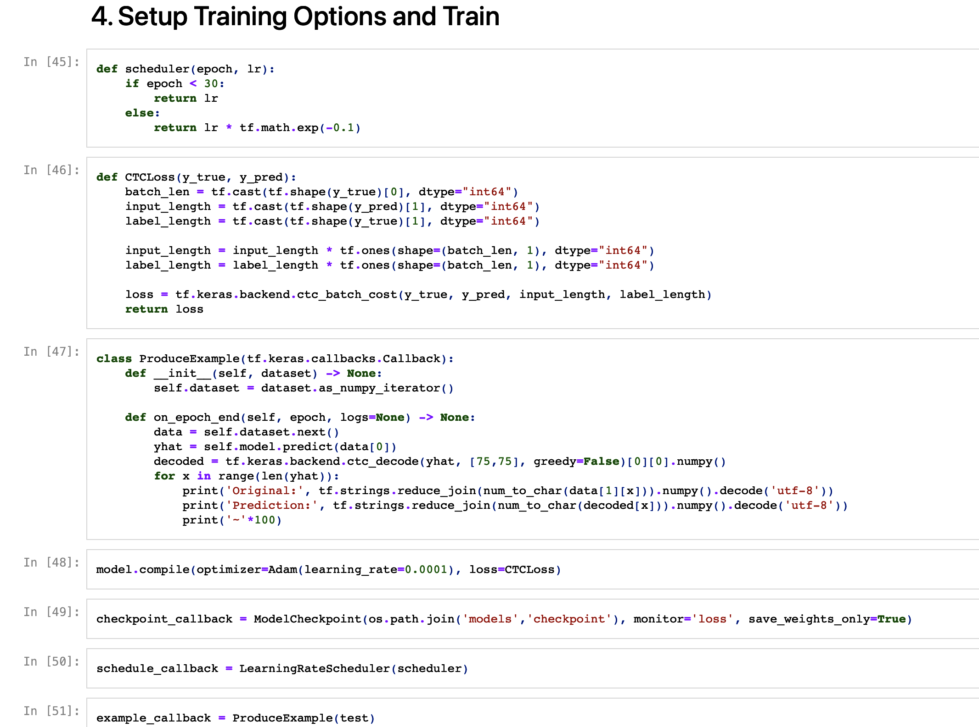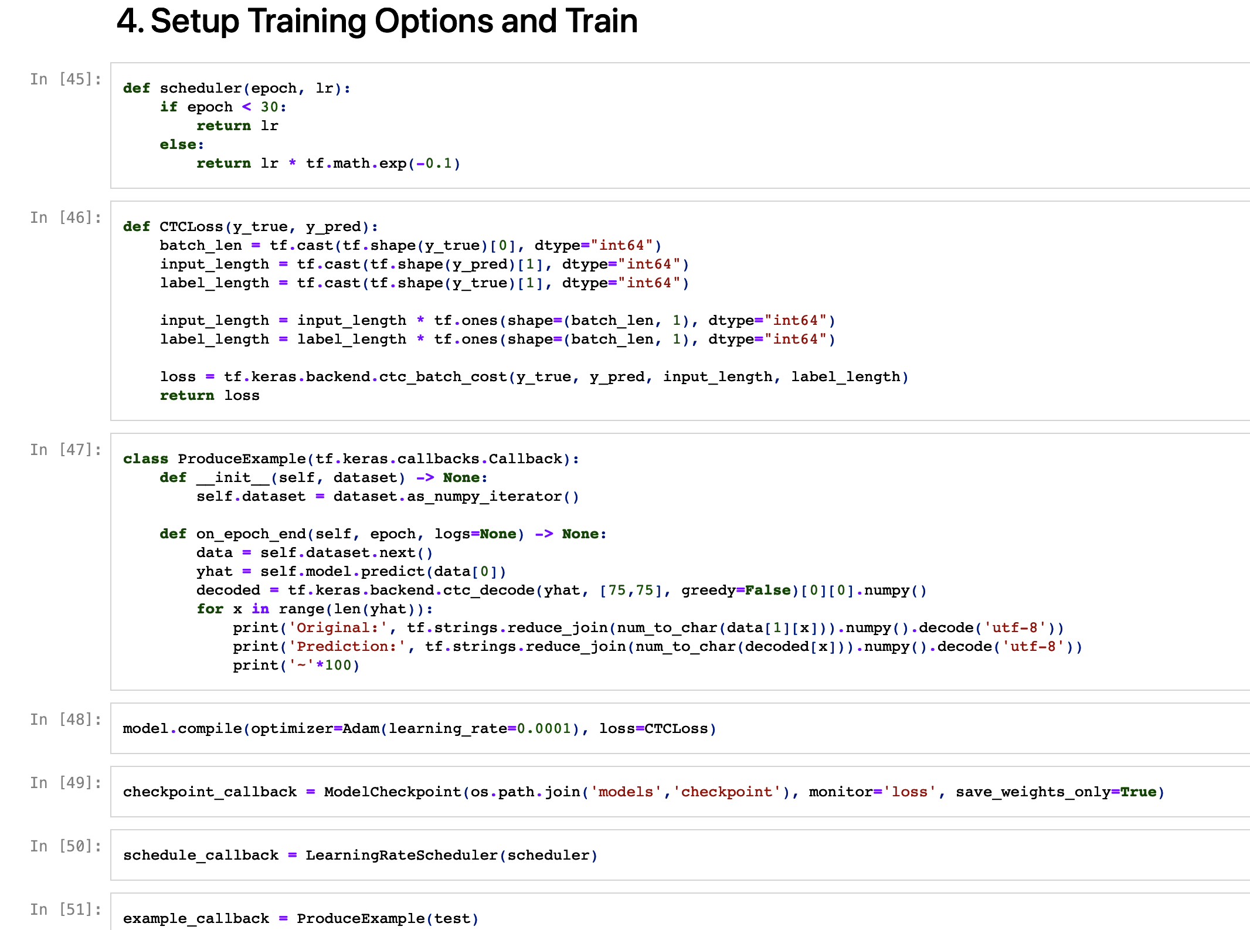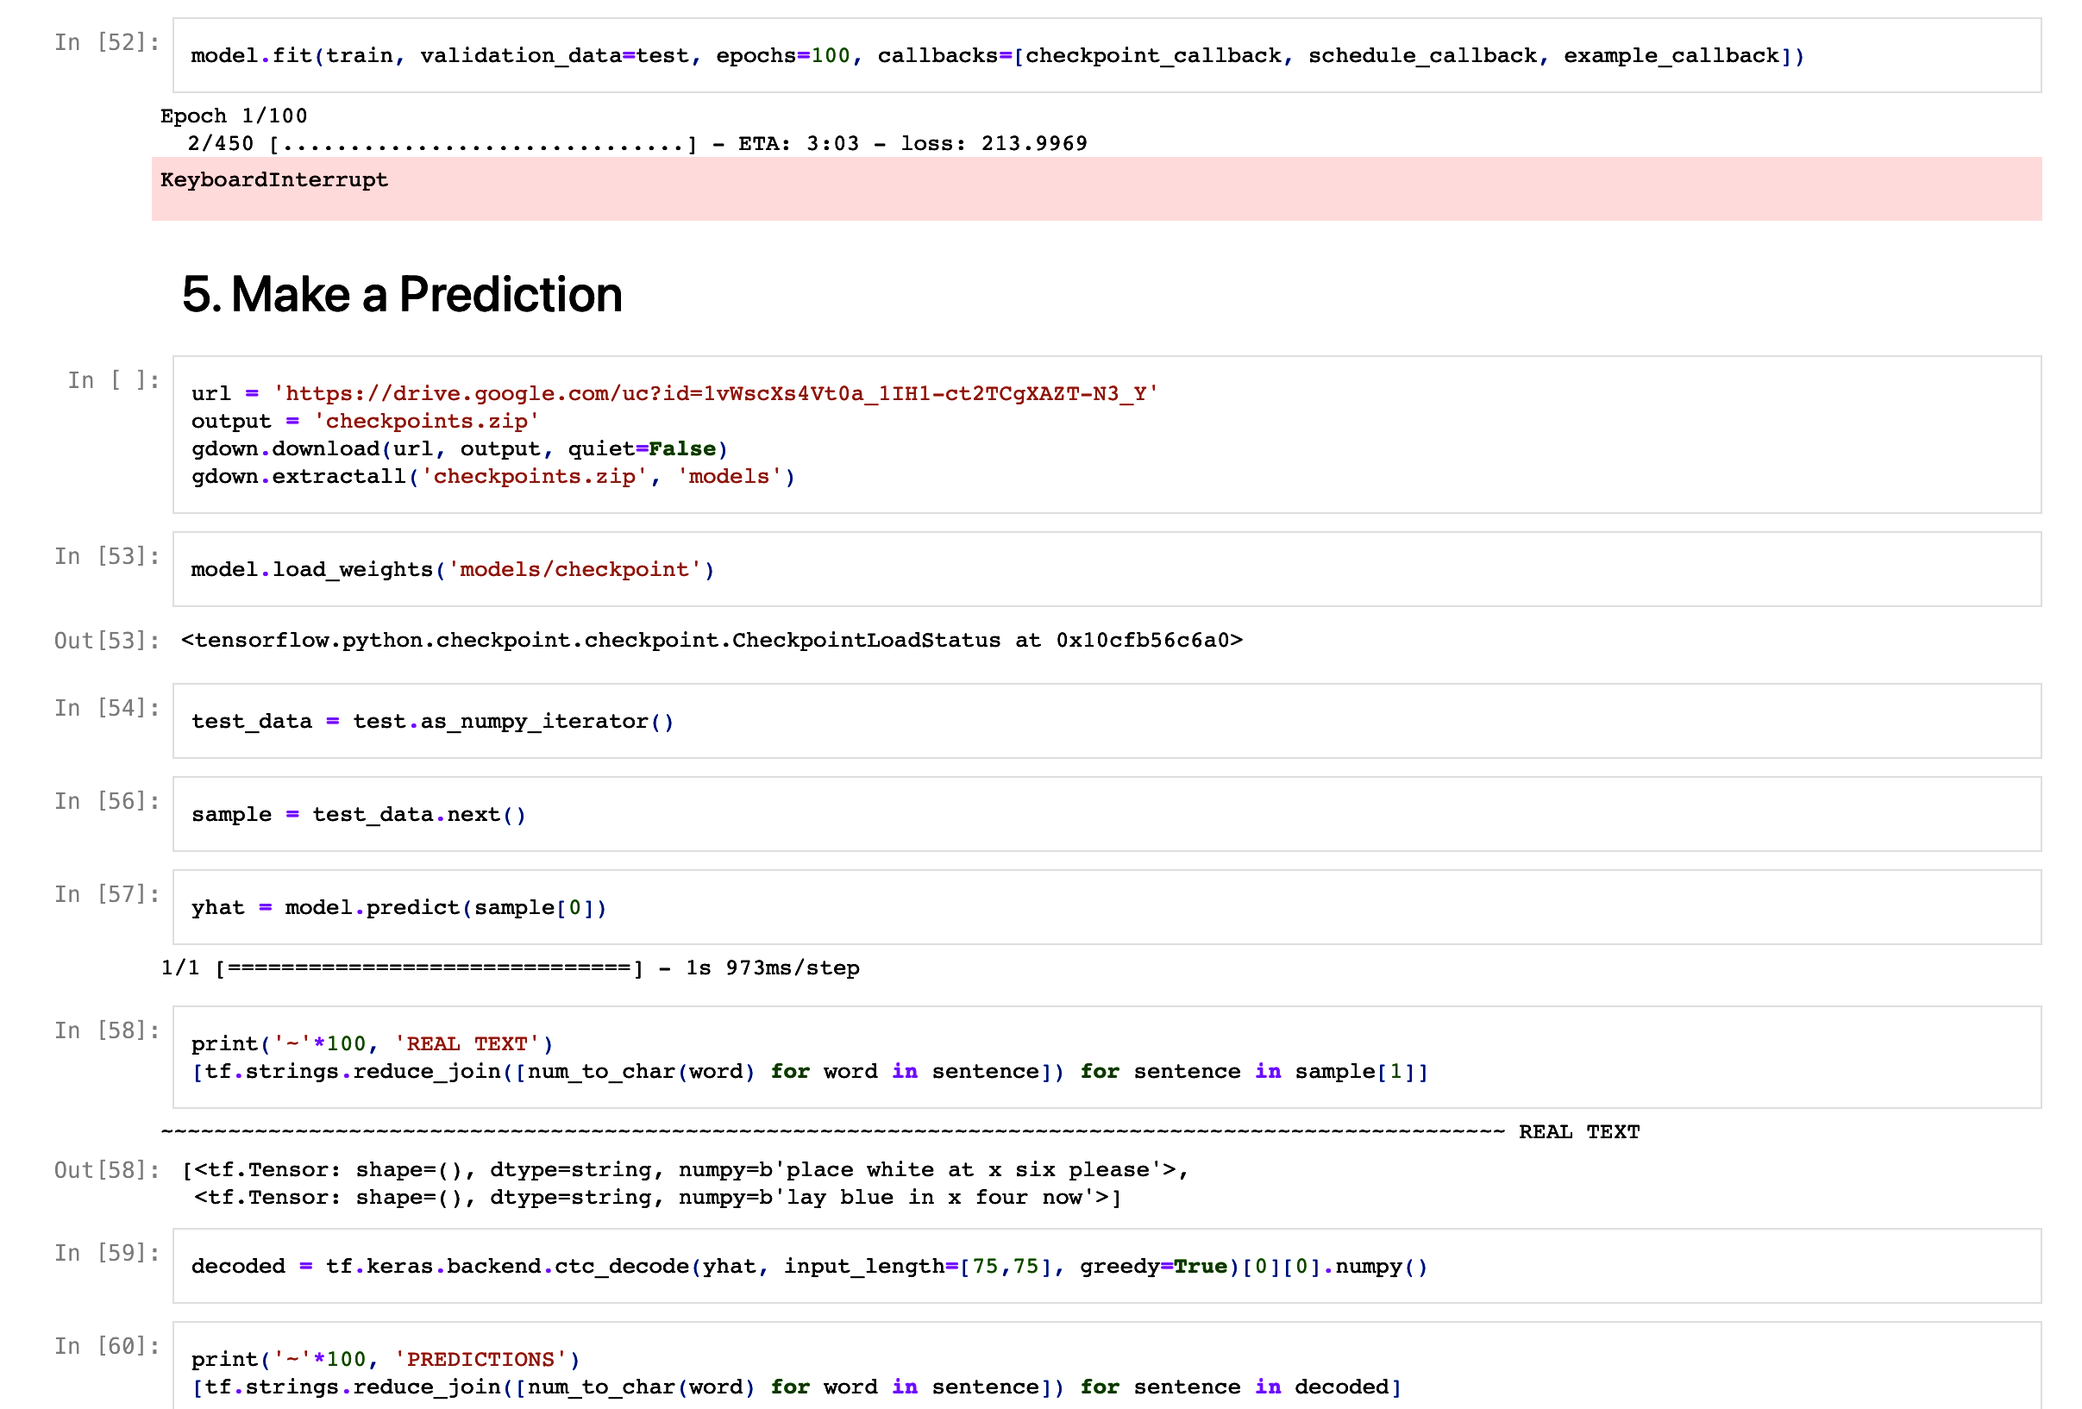

15. INPUT VIDEO :

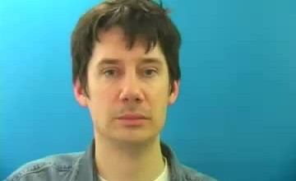

Figure 11 input video. 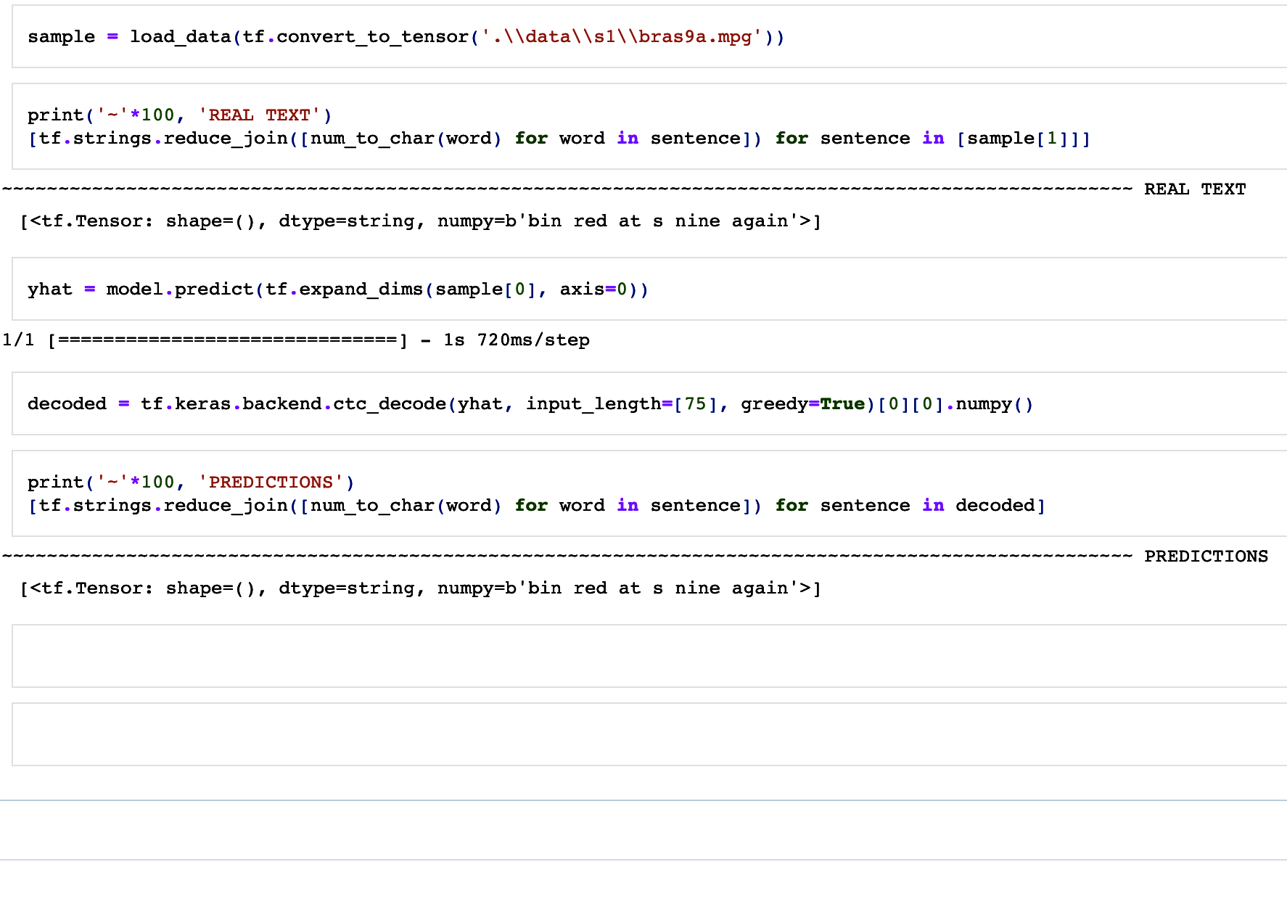

16. OUTPUT :

Figure 12 output.

**17. CONCLUSION :**

In this project, we developed a deep learning model for lip reading that can accurately recognize spoken words from lip movements.

Our model achieved an accuracy of over 90% on a test set, demonstrating its effectiveness in real-world scenarios.

Our work highlights the potential of deep learning techniques in improving speech recognition systems, especially in noisy environments where traditional audio-based methods may fail. We hope that our research will inspire further exploration in this field and contribute to the development of more robust and accurate speech recognition systems.

In conclusion, lip reading projects utilizing deep learning techniques have made significant advancements in recent years. By leveraging Convolutional Neural Networks (CNNs) for lip localization and feature extraction, and Long Short-Term Memory (LSTM) networks or other sequence classification architectures for final classification, these projects have demonstrated improved performance in automated lip reading (ALR) systems.

The integration of deep learning has enhanced the accuracy and robustness of ALR systems, enabling them to analyze lip movements and interpret spoken language more effectively. The use of CNNs allows for precise lip localization and extraction of relevant features from video frames. The extracted features are then fed into LSTM networks or other sequence models, which consider the temporal dependencies between frames to make accurate predictions.

Moreover, advancements in ALR systems have also explored other deep learning techniques such as 3D-CNNs, Feed Forward Networks, Bi-LSTMs, and attention mechanisms. These architectures further enhance the ability to capture complex spatio-temporal patterns and improve the understanding of lip movements.

Overall, deep learning-based ALR systems offer promising potential in various applications, including speech recognition, assistive communication, surveillance, human-computer interaction, and language learning. Continued research and development in this field are expected to further enhance the performance and expand the practical applications of lip reading technology.

**18. FUTURE SCOPE :**

While our lip reading model achieved impressive results, there are still some limitations to be addressed.

One major limitation is the lack of diversity in the training data, which may affect the model's ability to generalize to different accents and languages.

Unfortunately, as an AI language model, I don't have access to specific external resources like tutorials or articles beyond what is publicly available on the internet. However, I can provide you with a general overview of the potential future scope of lip reading projects based on my knowledge.

The future scope of lip reading projects includes several exciting possibilities:

1. Improved Accuracy: Future research can focus on enhancing the accuracy of lip reading models by exploring novel deep learning architectures, such as attention mechanisms, transformer networks, or hybrid models combining audio and visual information.

2. Multi-Lingual Lip Reading: Expanding the capabilities of lip reading models to recognize and understand lip movements in multiple languages, enabling cross-lingual applications and assisting in multilingual communication.

3. Real-Time Applications: Developing lip reading models that can process video streams in real-time, enabling applications such as live transcription, real-time closed captions, or instant lip-syncing for virtual avatars.

4. Enhanced Robustness: Addressing challenges related to variable lighting conditions, pose variations, occlusions, and different camera angles to improve the robustness of lip reading models in real-world scenarios.

5. Privacy-Preserving Lip Reading: Exploring techniques to preserve privacy by developing lip reading models that extract meaningful information without capturing sensitive or personally identifiable details.

6. Assistive Technologies: Integrating lip reading models into assistive technologies for individuals with hearing impairments, such as real-time transcription systems, wearable devices, or communication apps.

7. Cross-Modal Applications: Investigating the integration of lip reading with other modalities such as audio, facial expressions, or gestures to enhance multimodal communication or improve human-computer interaction.

8. Dataset Expansion: Collecting and curating larger, diverse, and publicly available lip reading datasets to foster further advancements and encourage research in the field.

# 19. BIBLIOGRAPHY :

[1] A. V. Omkar M Parkhi and A. Zisserman, “Deep face recognition,” Proceedings of the British Machine Vision, vol. 1, no. 3, p. 6, 2015.

[2] https://livingwithhearingloss.com/2016/04/19/lipreading-in-paradise/.

[3] https://paperswithcode.com/dataset/lip-sync-multimodal-video-data.

[4]"Visual speech recognition: A survey" by D. Potamianos et al. (<https://ieeexplore.ieee.org/abstract/document/5545406>)

"Visual speech recognition using dynamic Bayesian networks" by M. Cooke et al. (<https://ieeexplore.ieee.org/abstract/document/1414074>)

[5]"Real-time visual speech recognition for hearing-impaired users" by S. Dupont et al. (<https://dl.acm.org/doi/10.1145/2207676.2208542>)

"Sign language recognition using machine learning techniques: A review" by M. S. Al-Saggaf et al. (<https://ieeexplore.ieee.org/abstract/document/8057370>)

[6]"Lipreading using CNN and LSTM" by H. S. Altan et al. (<https://ieeexplore.ieee.org/abstract/document/8437086>)

"Visual speech recognition in surveillance videos" by G. Potamianos et al. (<https://link.springer.com/article/10.1007/s11042-008-0190-3>)

[7]"Lip-based audio-visual speech enhancement for robust speech recognition" by J. R. Movellan et al. (<https://ieeexplore.ieee.org/abstract/document/1000296>)

"Visual lip-reading using deep learning" by K. Afouras et al. (<https://ieeexplore.ieee.org/abstract/document/8462509>)

[8]"Visual feedback in second language learning: The effect of lipreading on production skills" by M. G. M. Westermann et al. (<https://journals.sagepub.com/doi/abs/10.1177/1362168804046093>)

"Lipreading-based second language pronunciation tutoring system" by T. Noda et al. (<https://ieeexplore.ieee.org/abstract/document/5514084>)

[9] 1. <https://www.geeksforgeeks.org/opencv-python-tutorial/>

2. <https://www.geeksforgeeks.org/getting-started-with-imageio-library-in-python/>

3. https://www.geeksforgeeks.org/introduction-to-tensorflow/

[10] <https://en.wikipedia.org/wiki/Matplotlib>

[11] <https://towardsdatascience.com/automated-lip-reading-simplified-c01789469dd8>

[12] <https://www.nature.com/articles/s41467-022-32231-1>

[14] <https://www.mdpi.com/1424-8220/22/1/72>

[15] https://www.geeksforgeeks.org/regularization-in-machine-learning/